Resistance and Resistivity Lab Report

Student’s Name
Submission Date

Aims and Objectives
This objectives of this experiment were to understand how to connect an electric circuit, to establish how a multi-meter is used, and to learn how to measure both resistance and resistivity.

The Experiment equipment
The following equipment were used during the experiment: a multi-meter, two unknown known resistors, leads, a Nichrome wire mounted on a board, and a dc power supply.

Theory
The potential difference between two points in a circuit is determined by the use of a voltmeter. The current flowing through a circuit is measured by an ammeter. The resistance of a resistor is measured by the use of an ohmmeter. The resistance of a resistor can be obtained by the use of three methods, namely: by the use of an ohmmeter, by the use of a voltmeter and an ammeter, and by the use of the bands on the resistor.
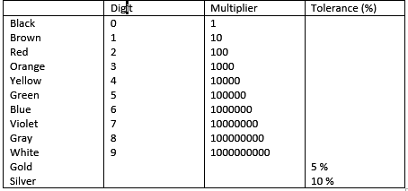
The method of using bands uses the colors in their order of appearance to determine the resistance. The figure below shows a table showing the values of each color.
Figure 1: The table of colors of the bands on resistors

The procedure of the experiment
Part A: Measuring Resistance
- Using an ohmmeter
The resistance of two unknown resistors was measured using an ohmmeter using two different multipliers. The readings were recorded in the data sheet.
- Using a voltmeter and an ammeter
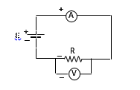
The circuit was set-up as shown in the figure below, without turning the power on yet.
Figure 2: The circuit for measuring resistance using an ammeter and a voltmeter
Then, the power was turned on and the voltage was adjusted to 1V. The ammeter and voltmeter readings were observed, recorded in the data sheet. This step was repeated for the second unknown resistor.
- Using the bands on the resistor
The color bands on the resistors were observed and recorded in the data sheet in the same order they appeared in the resistors.
Part B: Resistivity
Procedure: The dial was turned to ohms on the multi-meter and an appropriate multiplier was selected. The probes of the ohmmeter were touched to segments A to B, and its resistance recorded in the data sheet. This was repeated to these set points: A and C, A and D, and A, and E.

The Results, calculations, and Questions
The following tables represent the tabulated data from the experiment.
Measuring Resistance:
a) Using the ohmmeter

 | R (Ω)
Resistor 1 | 677.1
Resistor 2 | 965

b) Using voltmeter and ammeter

 | V (V) | I (A) | R (Ω)
Resistor 1 | 20 | 0.027 | 740.74
Resistor 2 | 20 | 0.018 | 1111.11

c) Using the bands on the resistor

 | Color of Band
 | 1st band | 2nd band | 3rd band | 4th band:
Resistor 1 | blue | red | brown | gold
Resistor 2 | brown | black | red | gold
Calculations:

 | Color of Band
 | 1st digit | 2nd digit | Multiplier | Tolerance
Resistor 1 | 6 | 2 | 1 | 5
Resistor 2 | 1 | 0 | 100 | 5

 | R () | R ()
Resistor 1 | 62 | 3.1
Resistor 2 | 1000 | 50
Comparisons: The second resistor, resistor 2, exhibited a close range of the values obtained throughout the three methods i.e. 965 ohm, 1111 ohm, and 1000 ohm. On the other hand, resistor 1 exhibited large variability that would be possibly due to errors in measuring.
Resistivity results:
Segment | R (Ω) | Length (cm)
A – B | 4.4 | 50
A – C | 8.7 | 100
A – D | 13.1 | 150
A – E | 17.5 | 200

Calculations:
Cross-sectional area for d = 0.039 cm
$A=πr^{2}$ = 11.9*10 ^{– 4} cm²
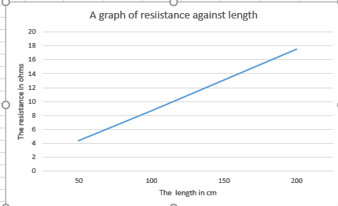
Figure 3: A graph of resistance against length

The slope is = change in y/ change in x = $\frac{13.1-4.4}{150-50}$ = 0.087 ohm/cm
The coordinates for resistance are 13.1 and 4.4, and for length are 150 and 50.
Slope * Area = 0.087 * 11.9*10⁻⁴ = 103.53*10⁻⁶
Percentage difference= (100*10⁻⁸ – 103.53*10⁻⁶)/ 100*10⁻⁸ = 10.25 %
The slope of the graph was found to be 0.087.
The units of area * slope are $\frac{ohm}{cm}$ *cm² = ohm.cm. The units represent resistivity.
Nichrome wire is preferred to copper wire because of its greater melting point, hence maximum current flows through Nichrome wire than in copper wire.
Yes, it is a reasonable assumption for the resistance of the meter and the posts to be zero, this is because the effect is compensated for thus minimum errors are realized from the \assumption.
The longest segment would cause the largest current flow if the power supply was connected to the board.

